# ICO converter

## Definition

**# Source**: **Windows ScreenShots (using Lightshot Program) From Site -> https://www.icoconverter.com/ at [8/29/2025]**

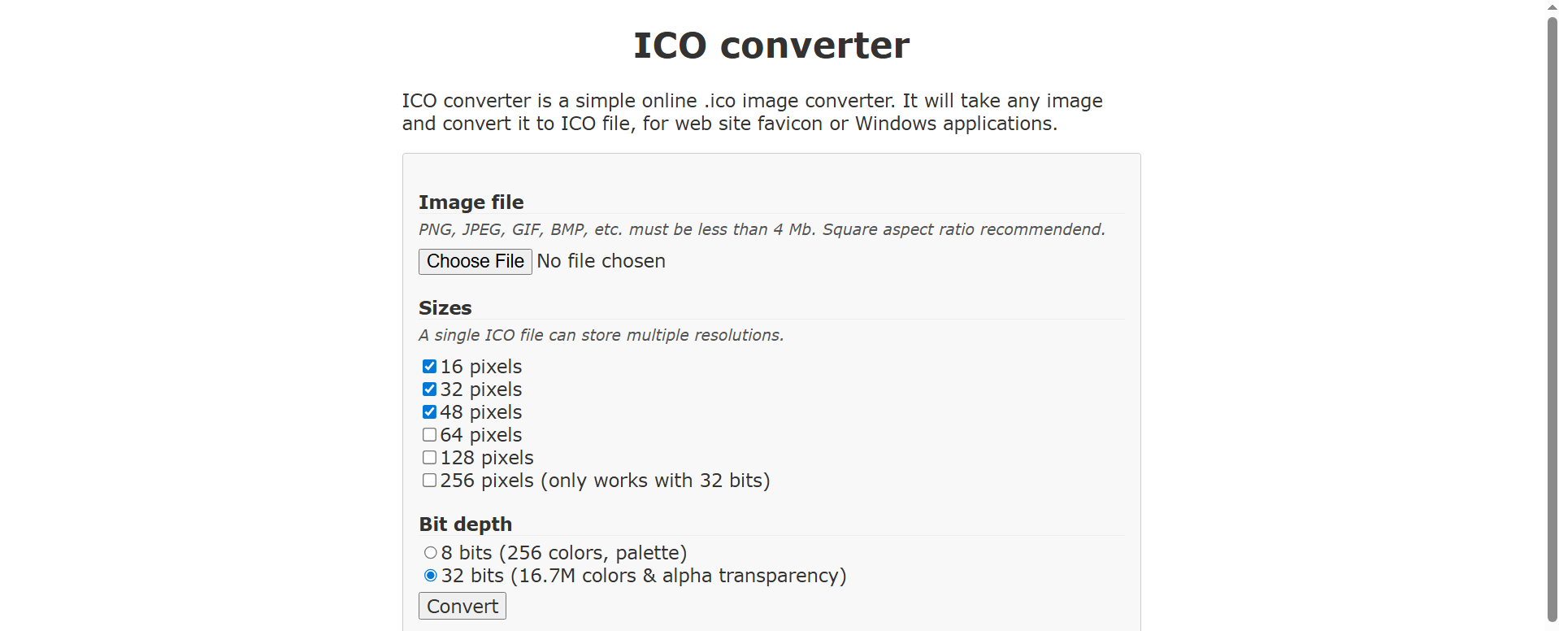

**# Source**: **Chatgpt (GPT-5-Standard) at [8/29/2025]**

ICO converter is a **free online tool** for converting images (like PNG, JPG, GIF, or BMP) into **ICO (icon) files**.

Since Windows requires **.ico files** for folder/shortcut icons, this site is used a lot when customizing game folders, app shortcuts, or desktop icons.

## Main Features of ICO converter:

**# Source**: **Chatgpt (GPT-5-Standard) at [8/29/2025]**

* **Image → ICO conversion** → upload a PNG/JPG/etc. and get a .ico.
* **Multiple sizes in one ICO** → lets you include 16×16, 32×32, 48×48, 64×64, 128×128, and 256×256 in the same file.
* **Transparency support** → keeps transparent backgrounds from PNGs.
* **Free & no install** → works directly in the browser.
* **Output options** → Windows XP style ICOs or Vista+ (with 256px, 32-bit).